C Program Tasks



Assignment title: C Program Tasks
Subject Name: Programming Fundamentals Lab
Submitted By: Nabiha Shaukat
Roll Number: 26k-3166
Submitted To: Sir Shayan Ali
Date Of Submission: 10 Sep 2026

QUESTION 01:
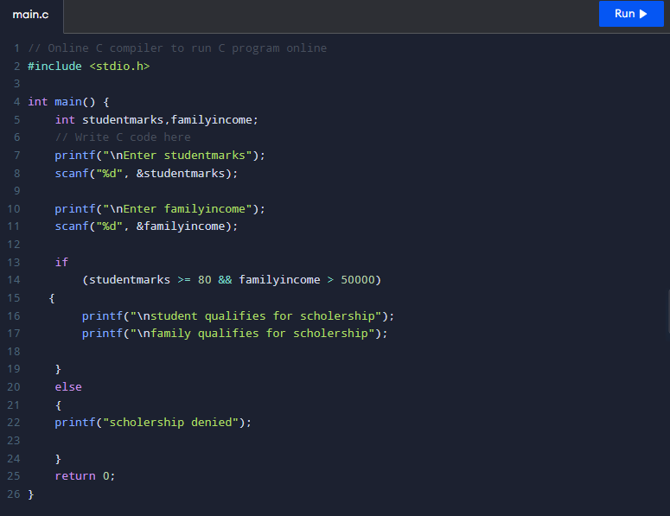Fig 1: Input of Scholarship eligibility criteria using if-else on C Compiler

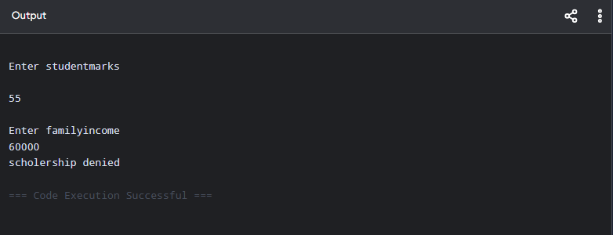Fig 2: Output of Scholarship eligibility criteria using if-else on C Compiler

QUESTION 01:
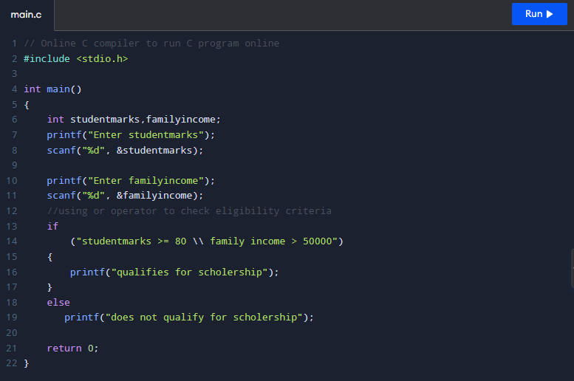Fig 3: Input of Scholarship eligibility criteria using OR Operator on C Compiler

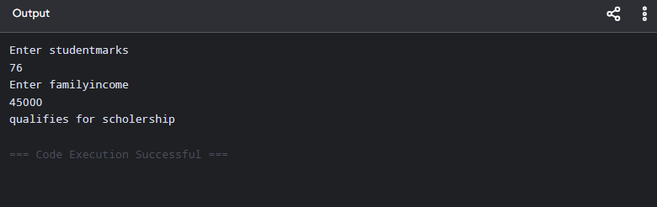Fig 4: Output of Scholarship eligibility criteria using OR Operator on C Compiler

QUESTION 02:
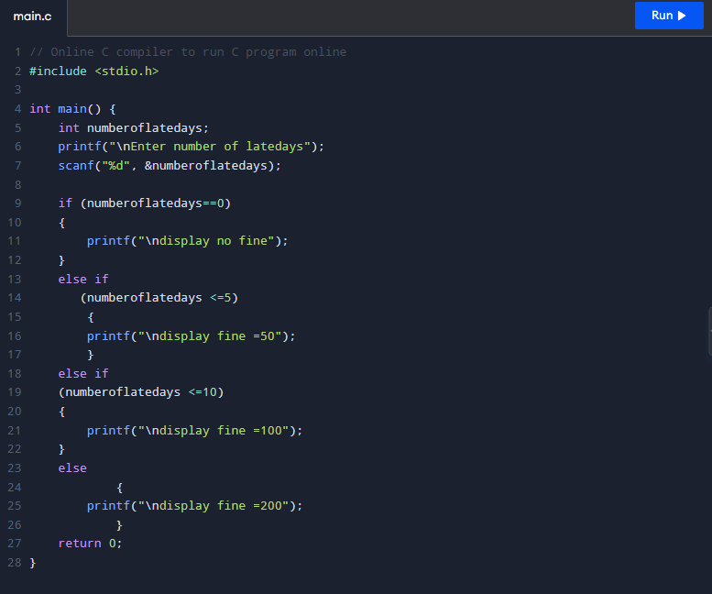Fig 5: Input of fine using if-else on C Compiler

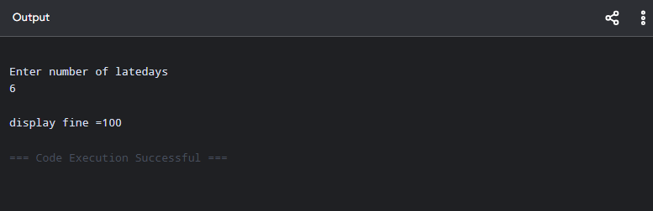Fig 6: Output of fine using if-else on C Compiler

QUESTION 03:
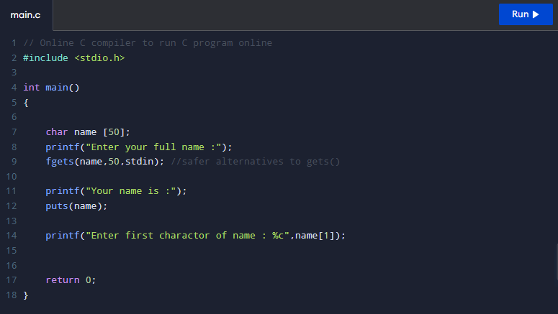Fig 7: Input of name & character using f-gets on C Compiler

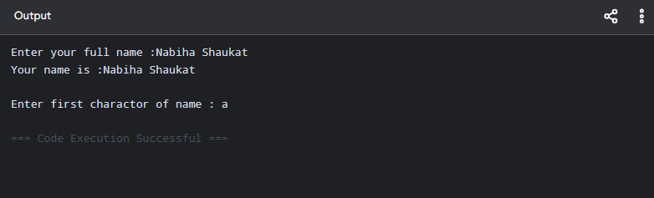Fig 8: Output of name & character using f-gets on C Compiler

QUESTION 04:
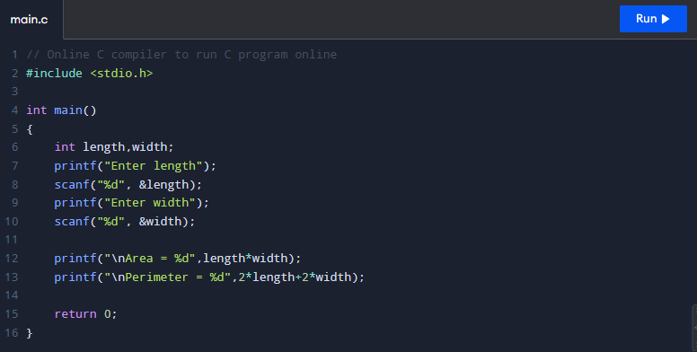
Fig 9: Input of area of rectangular room on C Compiler

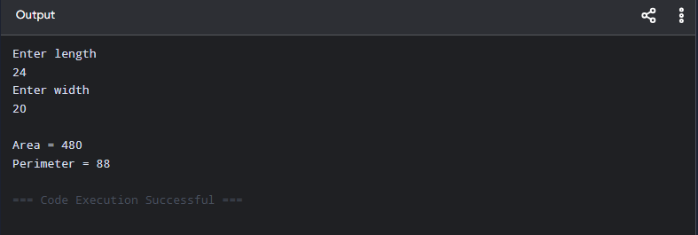Fig 10: Output of area of rectangular room on C Compiler

QUESTION 05:
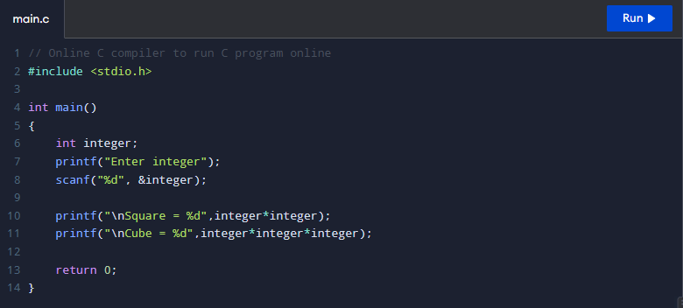Fig 11: Input of square & cube of an integer on C Compiler

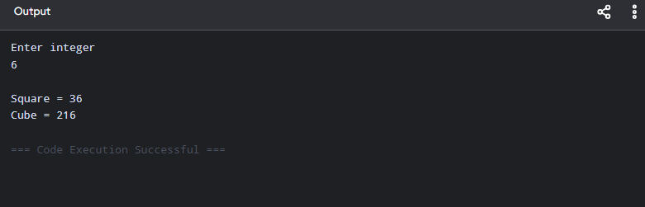Fig 12: Output of square & cube of an integer on C Compiler

QUESTION 06:
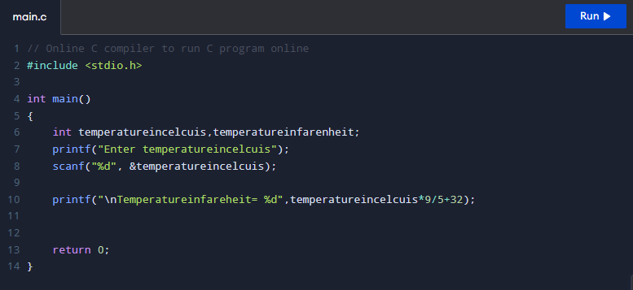Fig 13: Input of conversion of temperature on C Compiler

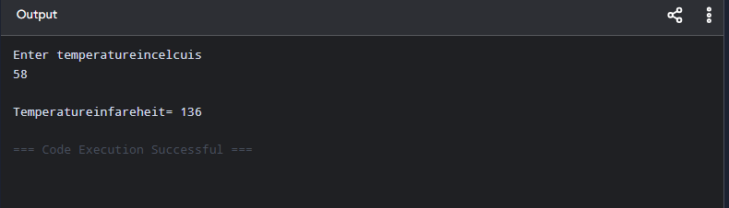Fig 14: Output of conversion of temperature on C Compiler

QUESTION 07:
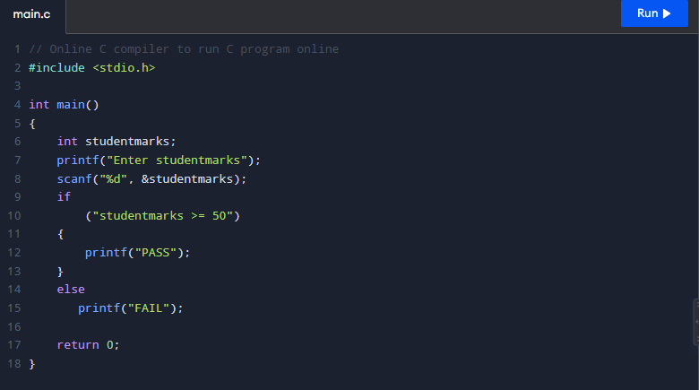Fig 15: Input of student marks using if-else on C Compiler

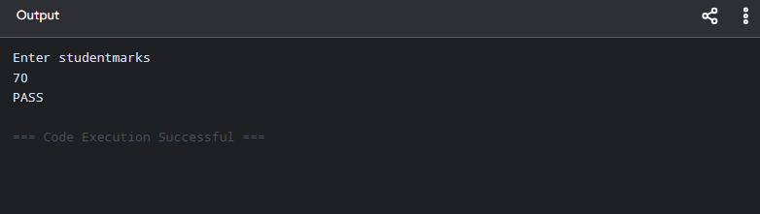Fig 16: Output of student marks using if-else on C Compiler

